Registration Form

The 6th International Conference on Advanced Communication Technologies and Networking (CommNet 2023).
- Participant*: Mr. or Ms
- Full name:__________________________________________________
- Author or non-author*:____________________________________
- Student or non-student*:__________________________________
- Presenter’s Full name*:___________________________________________
- Paper(s)’ ID(s)*:______________________________________________
- Institute/Company*:______________________________________
- Address*:_______________________________________________
- Zip code*:___________________________________________
- City*:__________________________________________________
- Country*:_______________________________________________
- E-mail*:________________________________________________
- Registration type* (Please specify here your choice from the table below; e.g., Author IEEE Member/Ordinaly-early):___________________________________________
Registration fees:
Please specify your choice from the table below

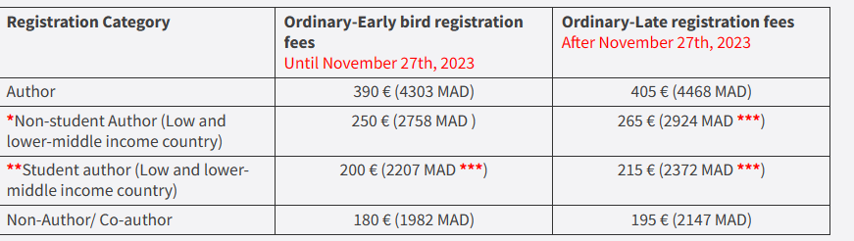

* To identify if The affiliations’ country is a low or lower-middle income country, check tables "LOW-INCOME ECONOMIES" and "LOWER-MIDDLE-INCOME ECONOMIES" on this link : https://datahelpdesk.worldbank.org/knowledgebase/articles/906519-world-bank-country-and-lending-groups
** The Non-student Author must be the first author of the paper, is from a low or lower-middle country and is UNEMPLOYED. This registration covers only one accepted paper
*** The student must be the first author of the paper, and is from a low or lower-middle country. Only UNEMPLOYED students are eligible for such a rate. This registration covers only one accepted paper.
**** The author must be the first author in his paper.

Important:
- Each Author/co-Author wishing to attend the conference must be registered.
- The amount in MAD for participants living in Morocco / performing the transfer from Morocco, per the latest currency change rate value.
- Extra additional paper registration: 100 €
- The above fees in the registration table do not cover any wire transfer costs.
- One registration is valid ONLY for one person. Furthermore, one registration covers only one paper on which the person who is registered is an Author or co-Author.
One Ordinary Registration for participants includes:
- Registering 1 paper,
- Access to Keynote Talks
- Access to Paper/Tutorial Presentations
- Coffee and refreshment breaks (on the conference facilities)
- Lunches on 11, 12 and 13 of December 2023
- A program book of the conference
- Electronic conference e-Proceedings
- Participation Certificate
Please return the first page of this Registration form filled and a copy of your bank transfer receipt by e-mail to ayoubfouadn@gmail.com. The paper EDAS # should be indicated in the subject of e-mail.
- Authors willing to register should indicate the presenter’s First and last name, if they are not the presenters of their accepted papers. Leaving the presenter’s full name field in blank means that the registrant is himself the presenter.
- Students should send a proof of their full-time student status and unemployment certificate.
CONTACT:
For any questions or concerns, please feel free to contact us at ayoubfouadn@gmail.com, f.elbouanani@um5s.net.ma.

